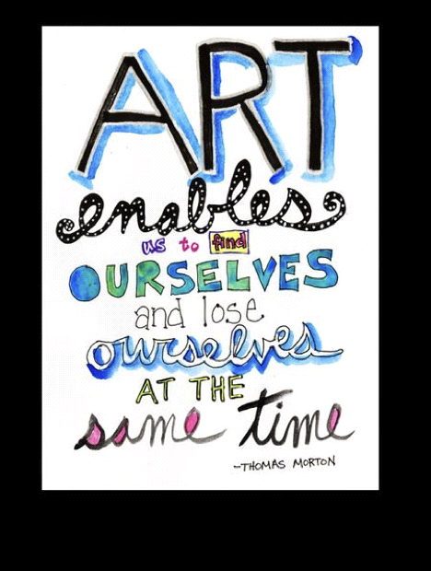THE ART OF WISDOM
SUMMER CAMP & CLASSES
Creating a Place of Belonging and Empowerment for Children

Mission Statement
The Art of Wisdom (TAOW) is a nonprofit community-based school in East Quogue, New York whose mission is to empower and educate children through a focus on art, imagination, and communication. With an art-based curriculum and lessons grounded in the Tao Te Ching philosophy, TAOW offers a variety of programs, including preschool, summer art camp, teen after school program and special event workshops.
Vision Statement
The Art of Wisdom is a place of belonging and empowerment for children. So, they can make loving and compassionate choices, so that each child can reach their full potential and become a responsible and caring adult.
It is not just an idea for a new type of school, or even just a passion which it is! It is a ‘Movement.’ The Art of Wisdom School is not based on any religion. It is based on the teachings of our greatest spiritual philosophers and visionaries, and the idea that when our children are taught that the traits of human kindness, empathy, forgiveness and love come first and foremost then everything else will follow, it is that simple. We feel that the two greatest words in our world are ‘Intention’ and ‘Connection’ This is why we follow the Tao The Ching philosophy very closely we take the lessons from the Tao and apply them to our school’s philosophy. As a child advocate it is extremely important that our school facilitates compassionate and loving, inspiring a cooperative nonviolent and joyful environment. Our school offers a humanistic, constructivist, and mindful program for the "whole child," inspired not only by the Tao Te Ching, but also by other forward-thinking philosophers, like Eckhart Tolle and Mahatma Gandhi who encourages us to question everything. However, if we look to the lessons that Jesus taught, it is easy to see that he was our greatest leader of mindfulness and peace. Specifically, when listening to the teachings of ‘The Sermon on the Mount’ he expresses how we should look to nature to see how effortlessly life can be if we just pay attention.
Our school is also community based, offering not only nursery and preschool but also after school art classes, summer and winter camp and other community-based programs including adult classes. Wherever you go, it is the staff that makes a school what it is. And the staff at The Art of Wisdom are all grounded in the same philosophy— that of nonviolent communication, and mindfulness. We embrace and nurture the ‘Whole Child,’ and allow each child to learn at his or her own pace. We believe an environment that provides children with the elements listed above is best suited for every child. Any person feels good in an environment that empowers them. Most importantly, we believe that each child is born with at least one special gift, and as teachers it is our job to recognize that gift and help the child to hone in and develop their gift as it emerges. Entering the child’s world right where they are and making learning exciting and fun. Our school is Art based encouraging our children to explore the many mediums that art has to offer we have also found that through art children open up. Our school makes beautiful unique pieces of art from recycled trash not only teaching the child to be conscious of the world we live in, but always encouraging the child’s imagination and showing them that you can create from anything and the first steps of creation always begins with a thought. Our program includes music so our children can embrace their inner soul and express their joy for life through dancing, singing and instruments. Our curriculum includes gardening so our children can learn about the cycle of nature. Our school makes salt dough from scratch, creating the whole alphabet. We believe that every moment is a lesson so we are always fully aware of the words we use and the energy we bring to the classroom. To sum it up we teach our children that we never touch anyone so lightly that we don’t leave a trace. Our school teaches our children about karma and the consequences that result from karma, every action has a reaction. That when you hurt someone you also hurt yourself, but when your kind to someone that kindness comes back one hundred-fold.
"Even a 1,000-mile journey starts with a single step" Lao Tzu

Our Discipline Approach
As Plato said: ”Do not train children to learning by force and harshness, but direct them to it by what amuses their minds. So that you may be better able to discover with accuracy the peculiar bent of the genius of each.”
We emphasize kindness and just behavior, always remembering to have respect for each other. Everybody has an opinion and everybody’s opinion counts. You will notice that every interaction between child and adult has a consistent and tangible feeling of respect and compassion. And when any conflict occurs, it is a true learning moment, and teachers are on hand for the children to resolve their own conflicts. We try not to rush to a resolution, but simply follow the child’s lead. Sometimes children can take a while to sort a conflict out to a place they deem to be “fair”. And we give them space to take the time to do that, while offering support, and helping them keeps bodies and hearts safe. We pay particular attention to where we are during the conflict. We stay on the sidelines. We don’t jump in reactively. If we notice our voice becoming louder, then that’s a signal to us to take a step back and let them have their own emotions about the conflict at hand. It’s pretty tricky, and it keeps us more awake as people. It is an incredibly magical thing to witness a couple of small children figure out a workable solution to their volatile dilemma…and then walk away laughing together, more emotionally and socially intelligent than before.
“The softest thing can overcome the hardest,
formless, it can enter where there are no gaps or space” Lao Tzu
To Conclude
Our camp is mainly child-directed. In other words, our teachers meet the children where they are. Not just physically, by getting down on the same level when we speak, but also energetically, by being in the moment, and celebrating in their successes, and joining them in the joy of creation. The children leaving our program understand more than just creating wonderful art projects. They have felt in their heart the steps of creation from beginning to end. They don’t only take their art projects home, but they take home pride and accomplishment. They are well developed in all realms, cognitive, emotional, and social:
“A Teacher takes a Hand Opens the Mind and Touches the Heart”

The Art of Wisdom
Registration Agreement
DATE___/___/___
CHILD’S NAME______________________Nickname___________________________________
Address_________________________________________________________________
Home Phone_____________________________________________________________
Date of Birth______________________Sex Male_____________Female___________
Father’s Name___________________Business Phone___________________________
Cell Phone_______________________ Home Phone____________________________
E-Mail Address__________________________________________________________
Occupation______________________________________________________________
Mother’s Name___________________________Business Phone__________________
Cell Phone_______________________ Home Phone____________________________
Occupation______________________________________________________________
Persons (other than parent) to be called in case of emergency (in order of preference)
1) Name________________________________________________Phone___________
Relationship to child______________________________________________________
2) Name____________________________Phone_______________________________
Relationship to child_______________________________________________________
3) Name____________________________Phone_______________________________
Relationship to child_______________________________________________________
Child’s Physician___________________________________Phone_________________
Are there any medical problems or information concerning your child we should be aware of?_______________________________________________________________
Days & classes your child will be attending____________________________________
Who is authorized to pick up your child _______________________________________
Is there anything special that we should know about your child? ___________________
________________________________________________________________________
Can your child have their photo / video taken to post on face book?________________
Can your child have their photo / video taken to post on our website? ______________
Can your child have tattoos? _______________________________________________
Can your child have face paint? _____________________________________________
Can your child have tattoos? _______________________________________________
Can your child have glitter tattoos? __________________________________________
Can your child have their hair beaded? _______________________________________
Can your child have their nails painted? ______________________________________
Can your child have hair chalk? _____________________________________________
Where did you hear about us? ______________________________________________
Can your child have ice pops?______________________________________________

PLEASE ATTACH IMMUNIZATION RECORD WHEN MAILING BACK
* First day of camp please send your child with a snack & drink NO NUTS! * One packet of Wipes * One plain white tee-shirt & an extra change of clothes labeled *

Daily Routine
Free Play
Getting to know each other
Art & Craft Time
Snack Time
Puppet Show / Story Time
Outside Recess / Water Fun
Face Painting / Home Time

All crafts we do at TAOW are done over a period of a few days (we are teaching our children anything worthwhile takes time & patience)
SUMMER @
THE ART OF WISDOM
(631) 974-5080
First day of camp please bring your child with their own snack & drink A towel labeled * Bathing suit * One plain white tee-shirt One packet of wipes * Please pack extra change of clothes labeled Before drop off please apply suntan lotion!
Please NO NUTS!!!
Please mail back registration form & Immunization record Please dress your child for a mess!
2019 Prices July 8th through to August 30th
To secure a spot for your child all payments must be paid in full as spots are limited! Enroll your child for the full eight weeks upfront and receive one week free!
All Classes run 3 hours * One day ~ $45.00 * Two days ~ $80.00 * Three days ~ $110.00 * Four days ~ $130.00 * Five days ~ $160.00 * Private Art Class ~ $25.00 a hour or $80.00 for four classes *

